1_5 Move Conveyor from A to B

- Download the project template from canvas. The name of the project template is EET231 PLCSIM and FactoryIO Template V16.
- Start the Siemens TIA Portal to launch the Project view.
- Click on open existing project and open the project template downloaded in step 1.
- Save the project with a new Project name as EET231_1_5_GP3_LastName
- Make sure you change the path where you will save your project to a path of your choosing.
- Next change the view to project view by clicking Project view at the bottom left corner.
- Expand PLC tags and double click on default tag table and create the tags shown in the I/O connection diagram below.
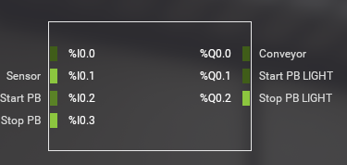
- Expand Program blocks as shown below.
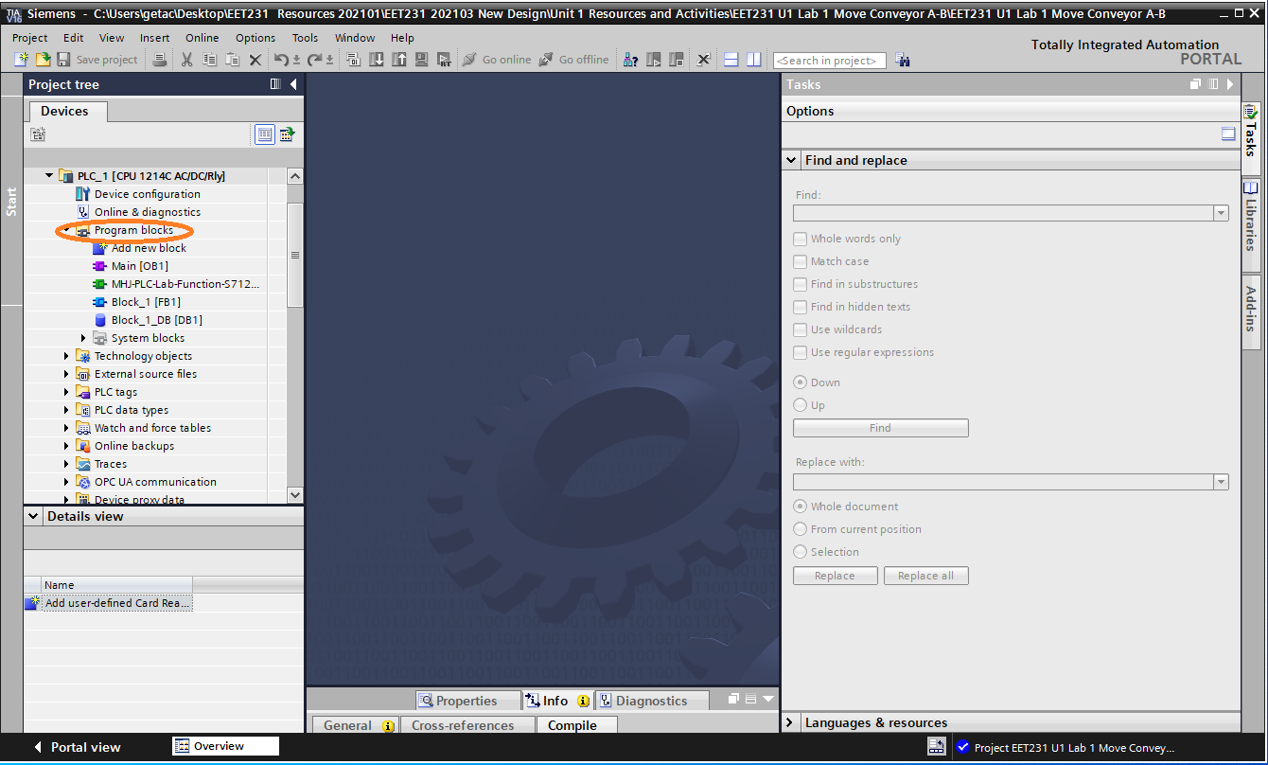

- Next double click Block_1 [FB1] function block and write the ladder logic program to perform the following task. (Use Lecture 3 – Slide 18 as an example)
  - Once Start PB is pressed, Conveyor will start until Stop PB is pressed.
  - Once the box detected by the photo sensor, the conveyor stops.
  - When the conveyor is running turn ON, Start PB light.
  - When the conveyor is not running turn ON, Stop PB light.
- After the program is successfully written, save and compile  the project.
- Next click on Start Simulation 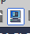 to begin the simulation.
- When the simulation starts, PLCSIM opens, wait until compilation finishes and the program is loaded to the PLCSIM.
- Click Load when the load preview appears.
- After configuration is loaded click finish and change PLCSIM to RUN mode by clicking on the RUN button.
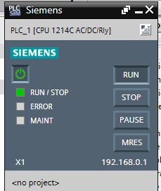
- You can turn Monitoring  ON to monitor the program.
- Now open Factory IO and open the scene provided by your instructor for this specific project.
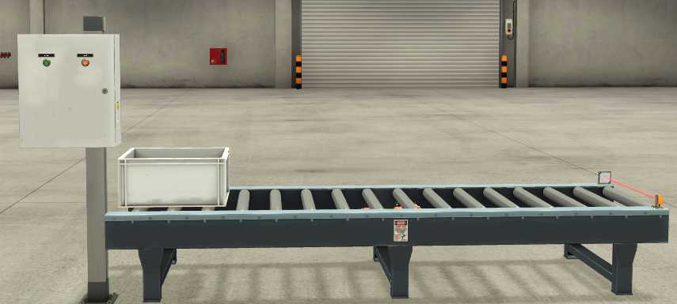

- Click File, then drivers (or hit F4 key) to look at the driver configuration.
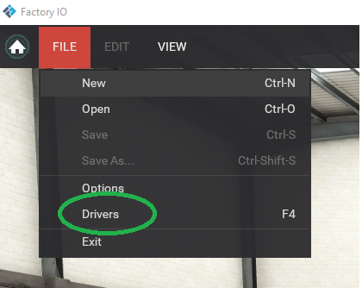
- Under drivers select PLCSIM the click Connect. Wait until the connection is established with your PLCSIM. You will see a green check mark if the connection is established.
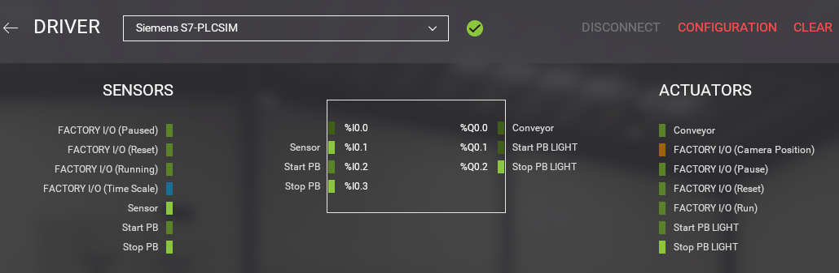
- Go back to the main Factory IO page by clicking on the left pointing arrow beside DRIVER.
- Click on run to start the simulation. Now you can test your program in operation by pressing start and stop buttons located on the operator panel with built in indicators.
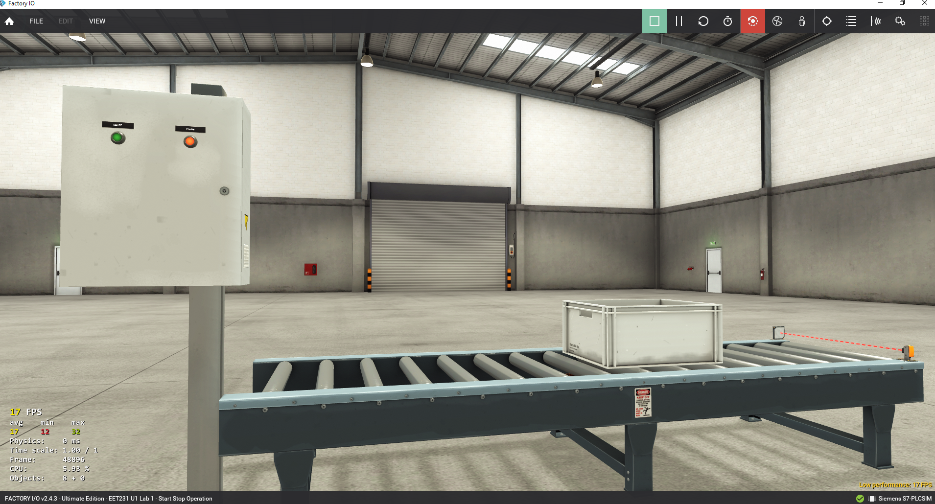
- You can monitor your program in TIA portal and modify any changes required to make it operational.
- 

 